ASSESSMENT TOOL 1
CO4 AT1 CODING CHALLENGE
NAME: CHANDRA KALA TORAM
REG NO: 192372224
COURSE CODE: CSA5110
COURSE NAME: CRYPTOGRAPHY AND NETWORK SECURITY
QUESTION 1: IPSec Authentication Header (AH) – MAC Generation & Verification
CODE:
import hashlib
import hmac
# Secret key
key = b"secretkey"
# IP packet/message
message = b"Hello, this is an IP packet"
# Generate MAC
mac = hmac.new(key, message, hashlib.sha256).hexdigest()
print("Original Message :", message.decode())
print("Generated MAC :", mac)
# Verification
received_message = b"Hello, this is an IP packet"
received_mac = hmac.new(
key, received_message, hashlib.sha256
).hexdigest()
print("\nVerifying Message...")
if hmac.compare_digest(mac, received_mac):
print("Authentication Successful")
print("Packet Integrity Verified")
else:
print("Authentication Failed")
print("Packet has been Modified")
OUTPUT:
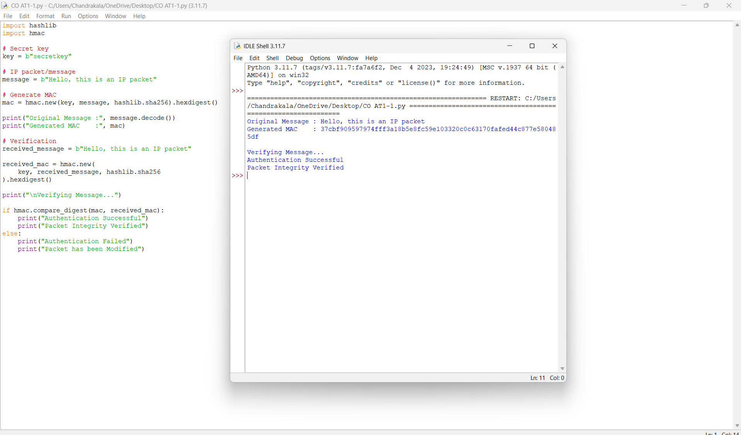
QUESTION 2: Security Association (SA) Management
This program performs the three required operations:
Create → Lookup → Delete
CODE:
SA = {}
def create_sa(sa_id, source, destination, algorithm):
SA[sa_id] = {
"Source": source,
"Destination": destination,
"Algorithm": algorithm
}
print("Security Association Created")
def lookup_sa(sa_id):
if sa_id in SA:
print("\nSecurity Association Found")
print("SA ID :", sa_id)
print("Source :", SA[sa_id]["Source"])
print("Destination :", SA[sa_id]["Destination"])
print("Algorithm :", SA[sa_id]["Algorithm"])
else:
print("\nSecurity Association Not Found")
def delete_sa(sa_id):
if sa_id in SA:
del SA[sa_id]
print("\nSecurity Association Deleted")
else:
print("\nSecurity Association Not Found")
create_sa(
101,
"192.168.1.10",
"192.168.1.20",
"AES-256"
)
lookup_sa(101)
delete_sa(101)
lookup_sa(101)
OUTPUT:
